**Exhibit Hall**

Doors to outside

**Occupancy** 420

**Includes:** 160 chairs,

& Fifteen 8-foot tables

**Memorial Hall**

PEG BOARD

E

E

**L**

**L**

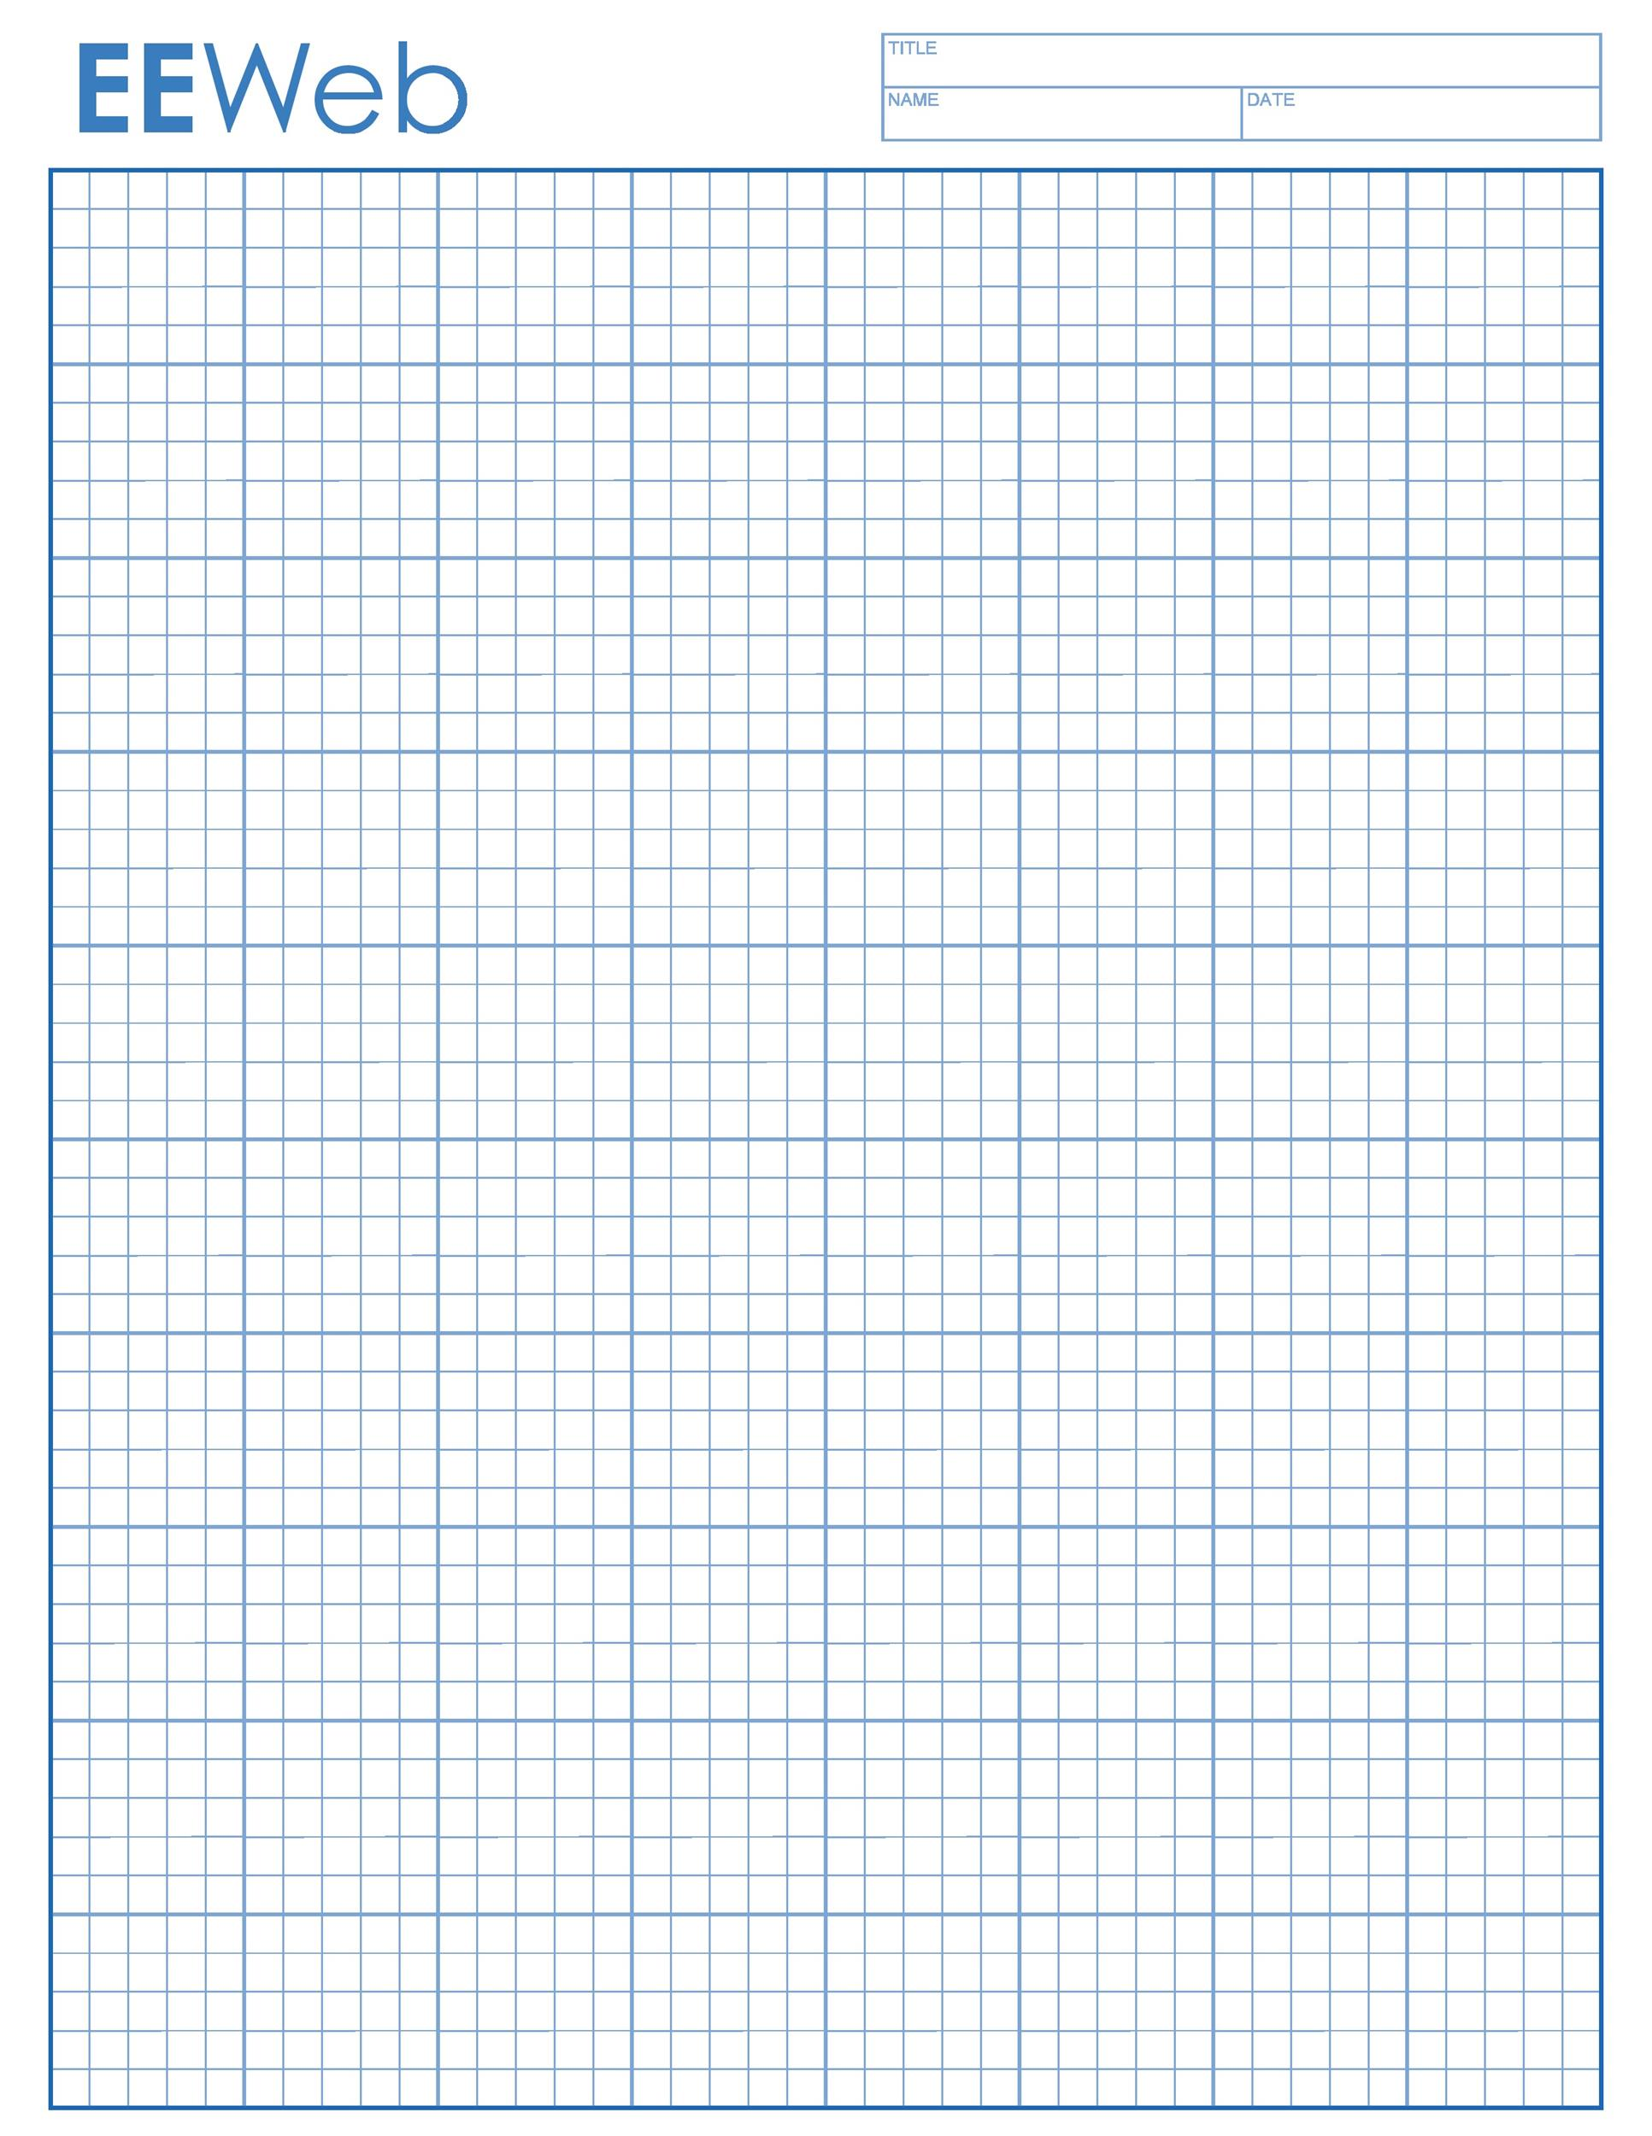

E

E

PEG BOARD

E

E

E

E=ElectricOutlet L=LightSwitch

Each Grid Square represents 2 feet

Pillar or Pony Wall

Main Entry

E

ANNEX (24x24)

E

Gentle RAMP

E

E

**Outside Doors**

PEG BOARD

E

PEG BOARD

E

E

E

E

E

E

E

E

E

E

E

E

E

E

BATHROOMS

Glass case