**Memorial Hall**

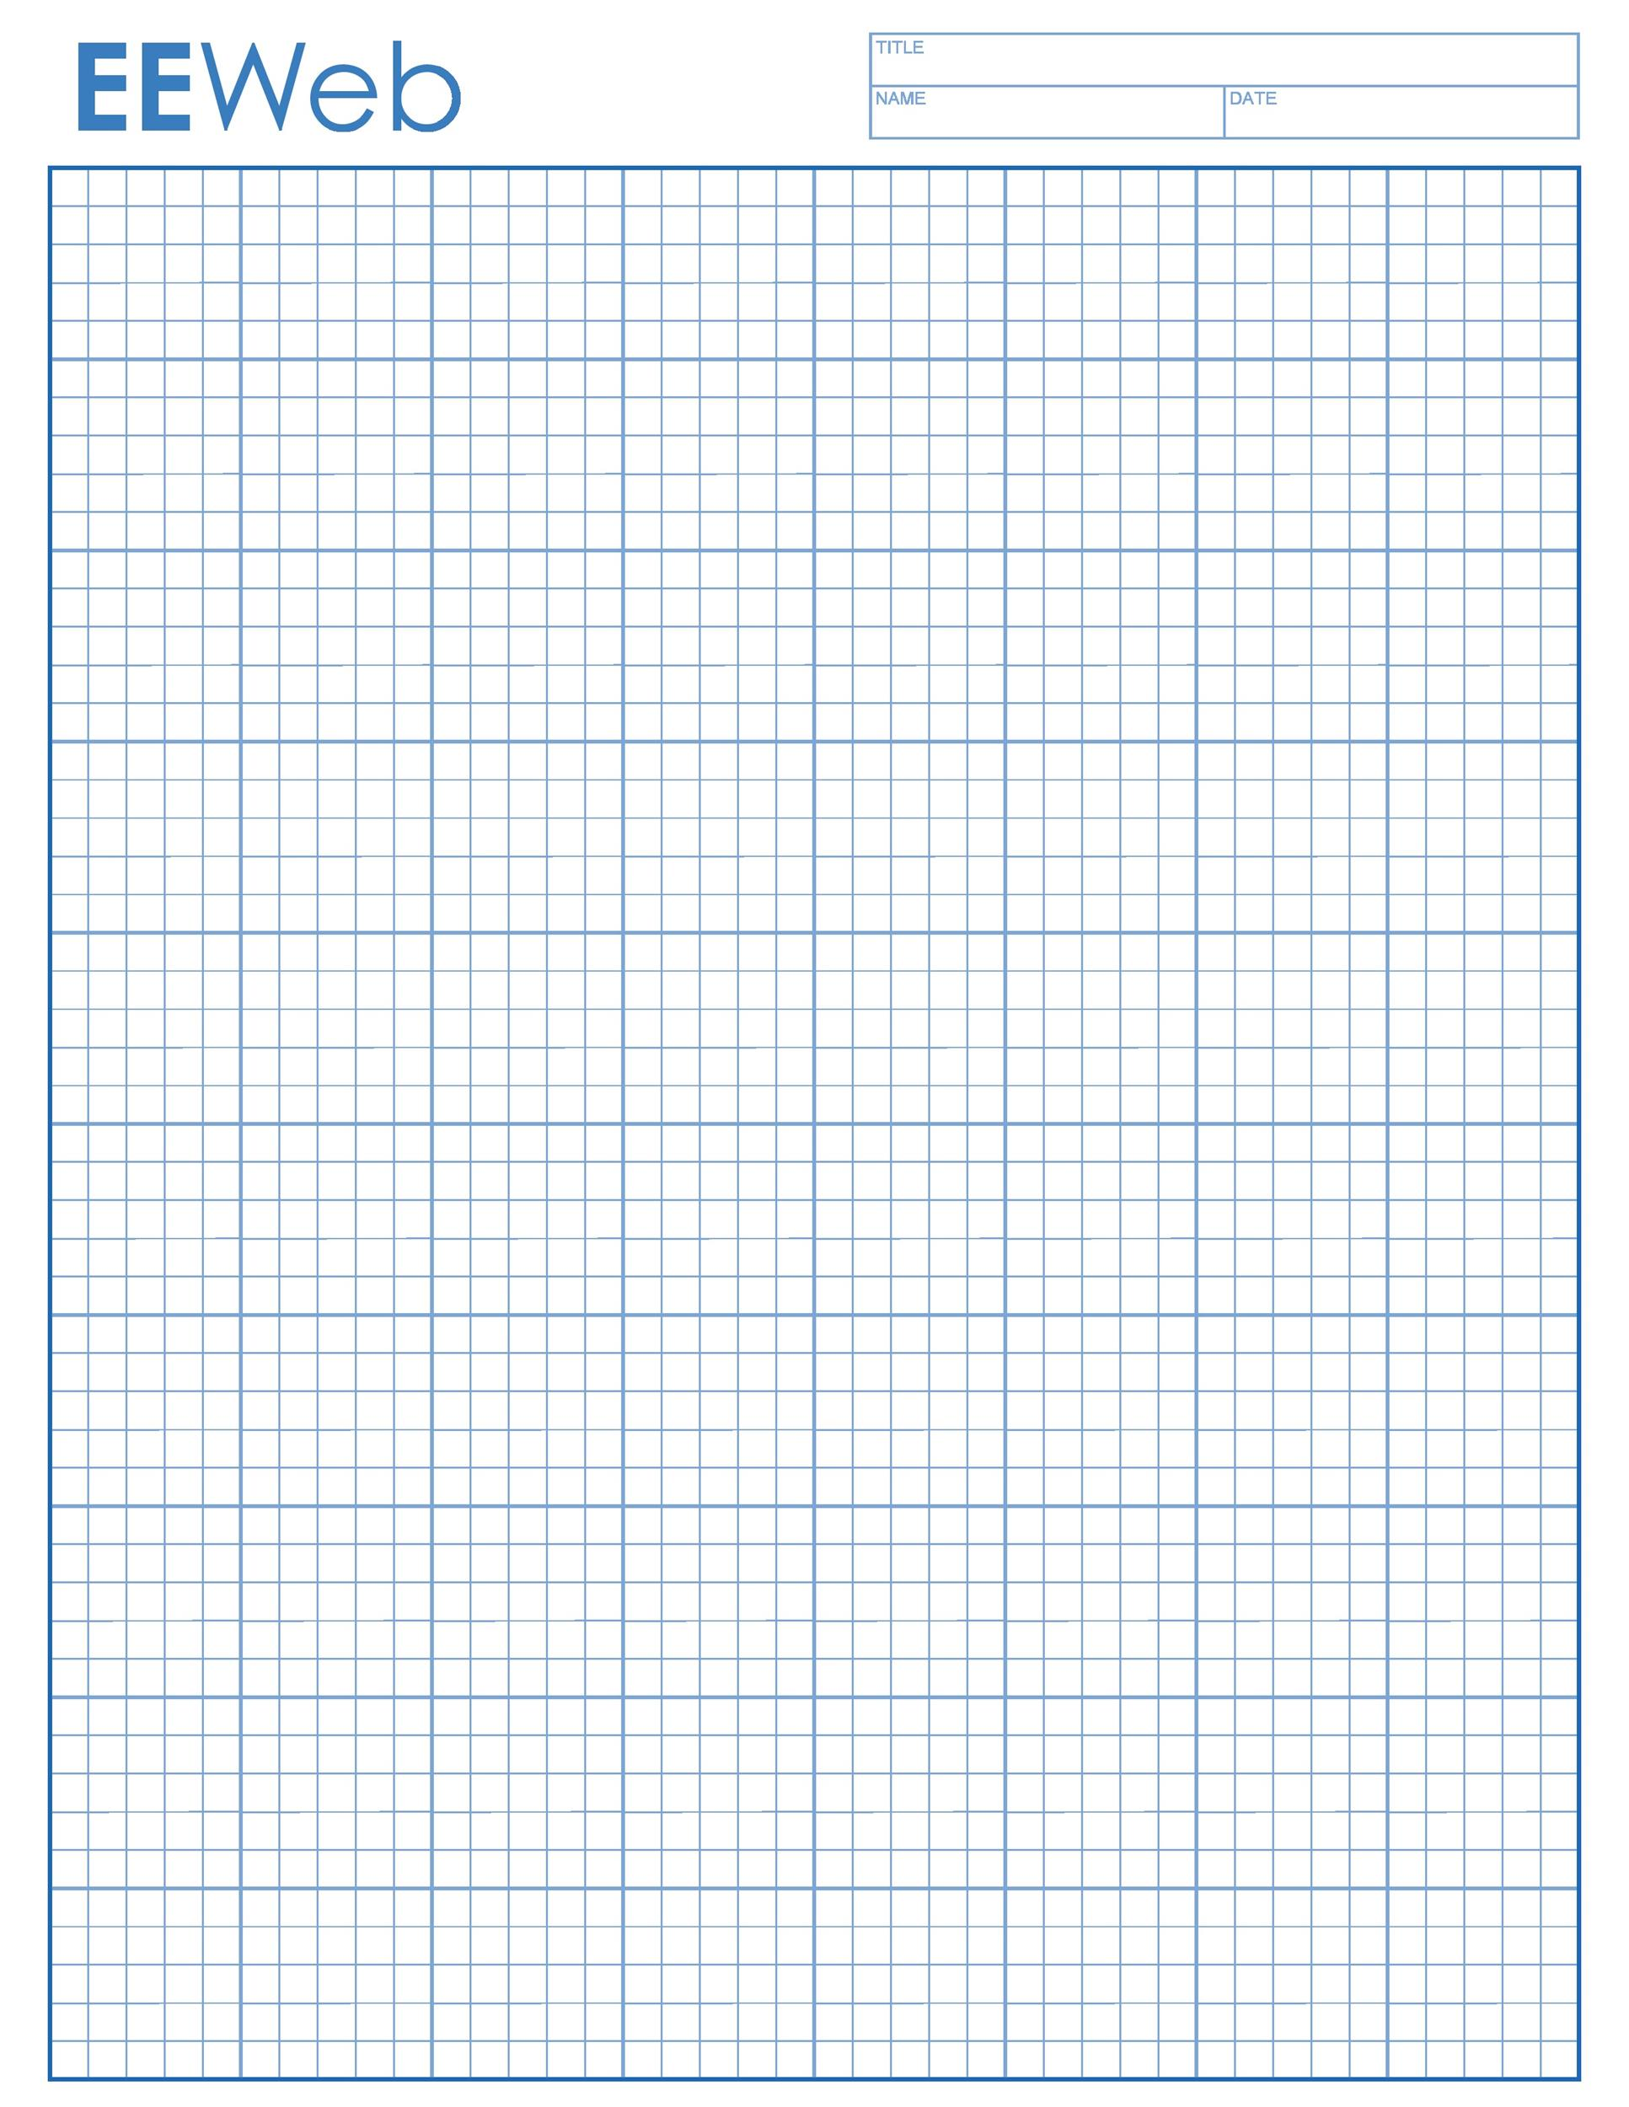

**Occupancy** 120

**Includes:** 25 chairs,

& Four 8-foot tables

Main Room 29x40

Plus Foyer/Storage/Coat Room

Plus full Kitchen (included)

Each grid = 2 feet

Doors To Memorial Hall

Island

Microwave

SINKS

Stove

Fridge

KITCHEN

E

**L L**

Windows all along parking lot wall

E

E

E

Church Benches

Church Benches

Church Benches

Church Benches

BATH-ROOMS x2

**Main Entry**

**Foyer**

**Coats**

**Foyer**

**Coats**

**L**

**PassThru Window**

E=ElectricOutlet L=LightSwitch

Each Grid Square represents 2 feet

E