**Valley Event Center**

Women’s Bathroom

Men’s Bathroom

Entry Door

FOYER

E

E

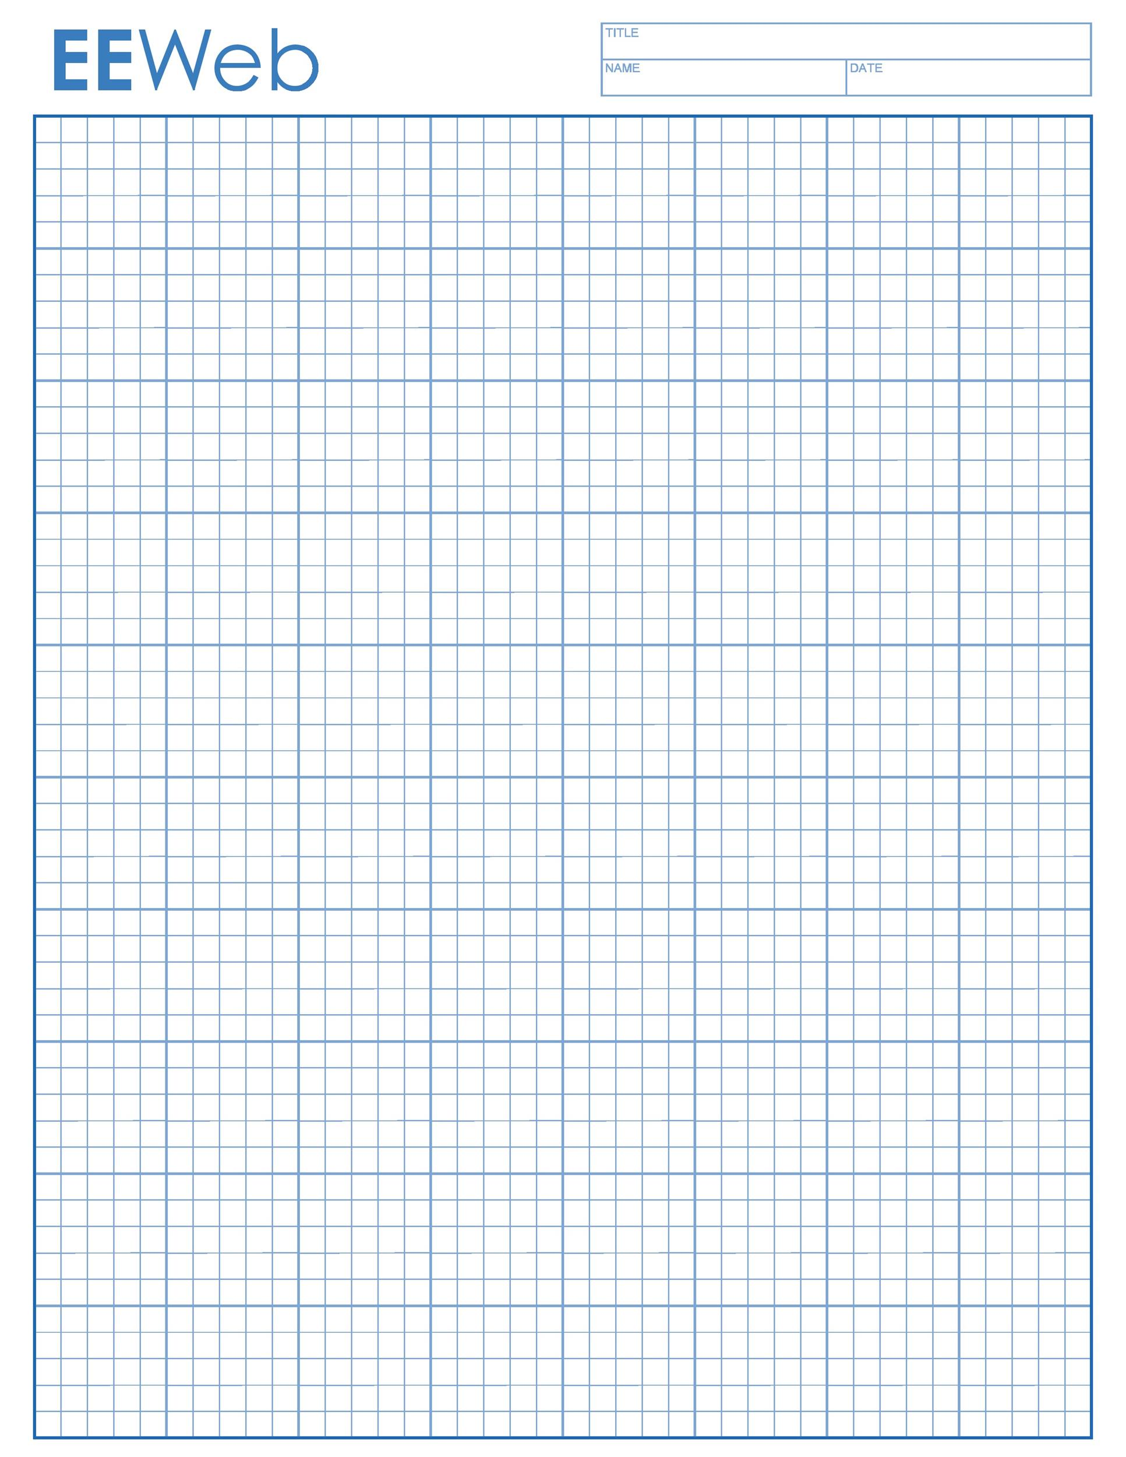

**Occupancy** 144

**Includes:** 24 round tables, 160 chairs, & 9 8-foot tables

23 X 96 feet

Each Grid Square represents 2 feet.

Commercial Kitchen attached, but rents separately (not included in price)

E

KITCHEN

Door to Patio

E=ElectricOutlet

W=Window

F=Furnace

L=LightSwitch

E

**L**

**L**

E

E

E

W

E

W

E

E

W

E

Outside Door

Outside Door

E

E

Outside Door

F

Kitchen Door

PassThruW

PassThruW

PassThru

E

E

PassThru

Kitchen Door

E

Outside Door

F

E

E

E

W

W

E

E

W